Swordsman Program

Pre-Order Form

Royal Rangers National Office

Please type or print. All information must be supplied, or this application will be returned. All forms are due by January 15, 2024. Once completed, submit this form directly to the national office for processing. Please allow at least (4) weeks from January 15th for the national office to process.

Royal Rangers Ministries FAX: 417-831-8230
1445 N. Boonville Ave. Email: rrawards@ag.org
Springfield, MO 65802-1894
- Name and address of Swordsman member.
Name |  |  |  |  |  |  | Phone
Address
City |  |  |  | State |  |  |  |  |  | Zip
Email address to send the Square invoice for credit card purchase

2. By purchasing the coin listed below, you are confirming you have met the requirement of reading the Bible for 208 days between January 1 and December 31 of 2023.
Quantity of items you wish to order.
 | Swordsman Patch* (A) | $0.99
 | Swordsman Lapel Pin* (B) | $4.99
 | Swordsman Pendant & Cord (C) | $9.49
 | Swordsman Coin (D) | $6.99
 | Swordsman T-shirt Youth Medium (E) | $13.99
 | Swordsman T-shirt Youth Large (E) | $13.99
 | Swordsman T-shirt Adult Small (E) | $14.99
 | Swordsman T-shirt Adult Medium (E) | $14.99
 | Swordsman T-shirt Adult Large (E) | $14.99
 | Swordsman T-shirt Adult XLarge (E) | $14.99
 | Swordsman T-shirt Adult 2XLarge (E) | $16.99
 | Swordsman T-shirt Adult 3XLarge (E) | $17.99
 | Swordsman T-shirt Adult 4XLarge (E) | $18.99
X | Note: There is a shipping/handling charge on all orders. | $4.00
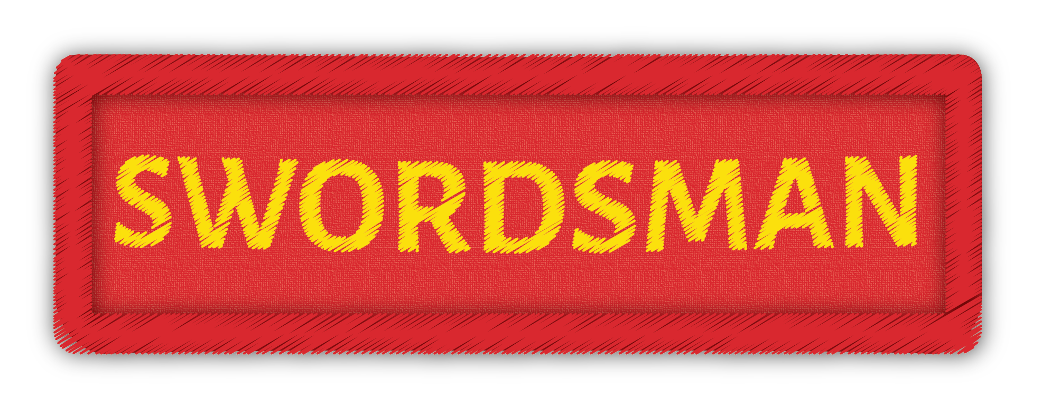A
A
NEW in 2023
E
D
B
C

